CURRICULUM VITAE

Manisha Kumari 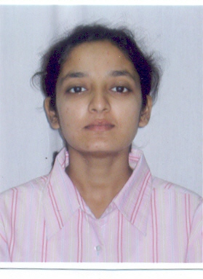

C/O-DR. UTKARSH SINGH
“MAYUR”ROAD NO-6 Email Id-manisha17n@gmail.com
RAJENDRA NAGAR,PATNA Contact No-91-9771403001
PIN-800016

Career Objective:

- To develop a career that would provide me an opportunity to keep contribution by utilizing my skills & abilities in challenging and dynamic environment to achieve organizational objective.

Project/Internship Programme:

- Five weeks training on Core Java at Ardent Collaborations, Kolkata.

- One week training on Telecom Networking at Bharat Sanchar Nigam Ltd (BSNL), Patna.

Technical Qualification:

- B.Tech. in Electronics and Communication Engineering (2005-09): Secured 7.74 DGPA from Techno India College of Technology, Kolkata under West Bengal University of Technolgy

Educational Qualification:

- Intermediate: Secured 75% marks in Intermediate from C.B.I. Inter College, Siwan (Bihar) under BIEC.

- Matriculation: Secured 61% marks in AISSE from Gyan Bharti, BodhGaya, Gaya (Bihar) under CBSE.

Software Proficiency:

- Diploma in Software Engineering from NIIT, Kolkata.
Personal Skills:

- Dynamic, Self-Confident, Willingness to learn team facilitator.

Language Known:

- English & Hindi.

Personal Profile:

Father’s Name : Sri Nirmal Kumar Sharma.
Mother’s Name : Smt. Asha Sharma.
Husdand’s Name: Dr.Utkarsh Singh.
Date of Birth : 17th Nov.1982.
Gender : Female.
Marital Status : Married.
Nationality : Indian.

Permanent Address:

C/O-Dr.Ajit singh
“Mayur”,Road No-6
Rajendra Nagar-Patna
Bihar.
Pin-800016
Contact No-09771403001

Declaration:

I do hereby declare that all the above given information are true to the
best of my knowledge.

Place:

Date: Signature.

